Week 1 Collective Worship WC 09.01.17
Teacher Lead- Miss Jones | Tuesday
REFLECTING ON THE WIDER WORLD  Matthew 2 1-12  Use images from around the world to show that the Magi are presented in particular ways to different cultures around the world  Show a range of images from different cultures- African Magi, Nativity images in Indian art etc. Art from Peru is also very distinctive.  Talk about how these images are the same but also different from those we see around us at Christmas time. | What might this show us about how we and others understand Jesus? The story of the Magi shows that, from the very beginning, Jesus was sent to all the nations and peoples of the world, who are now able to understand and worship him within their own context but also with all their brothers and sisters throughout the world.
Questions and thoughts from the children  Different people celebrate Jesus around the world and have different perceptions of him. –Thoughtful comment.  People might have different opinions about Jesus, as we do about all people.  Jesus is celebrated all over the world- Linked back to Assemblies before Christmas when we looked at different Nativity scenes. | Prayer/ Words of thought  May the name of the Lord be great among the nations  From the rising of the sun to its setting, now and for evermore  AMEN
Teacher Lead- Miss McComb | Wednesday
THE WISE MEN (MAGI) VISIT JESUS  Matthew 2 1-12  Re-visit the story in an appropriate version. Focus on the gifts brought to Jesus.  Use them to talk and pray about: | Golden times in the past year and in the year ahead (Gold for kingship))  People who need our prayers because life is sad or difficult (Myrrh for suffering)  How people help us to come nearer to Jesus and thank God for them (Frankincense for worship)
Questions and thoughts from the children  Children talked about our ‘time to shine’ Assembly when we celebrate golden times.  We discussed conflict around the world and how people are suffering around the world but also close to home.  People in the local area may also need our help, thoughts and prayers.  What can we do to help? Children discussed also giving money to charity- Supporting causes.  How can people feel nearer to Jesus? They may pray in Church, at home or talk to him anywhere. Some people feel that they are always looked after and watched over, wherever they are. | Prayer/ Words of thought  May the name of the Lord be great among the nations  From the rising of the sun to its setting, now and for evermore  AMEN
Teacher Lead- Class 4 | Thursday
Value for the Week- Generosity from the Values for Life File  Group included Amelia, Archie, Ben and Brooke.  Pupils discussed birthdays and parties asking what people might have and who they might invite.  Pupils then read the story of the Big Party from the Lion Storytellers Bible. Pupils asked the meaning behind the story and emphasised that showing generosity to the less fortunate and making sure everyone is involved is a key value. They discussed how God plans to invite everyone to heaven where it will be one big party.  Pupils showed the value of teamwork throughout the process of leading the collective worship. Pupils rehearsed the assembly together and shared out parts equally.  The school were respectful listening intently to the assembly and answering questions when called upon. | Reflection provided on display board.  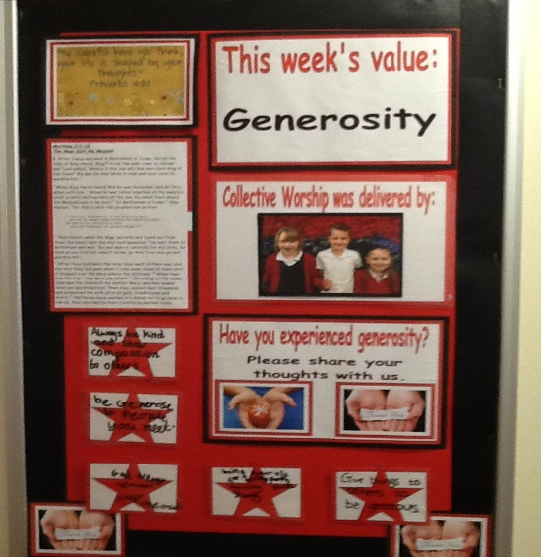  “Always be kind and show compassion to others.” Y6  “Be generous to people you meet.” Y3  “God never leaves anyone out.” Y2  “Be generous by letting people share your things.” Y2  “Give things to others to be generous.” Y5
Teacher Lead | Friday
Time to Shine
People shone for various reasons this week:
Improved behaviour and attitude to learning; Improvement in Literacy- particularly efforts with writing; Working independently and producing fantastic results; Creative ideas for writing.

