Year 5 & 6 Spr 1
French
The children will be able to name the points of a compass and explain how to use them to describe where they live in more detail. Furthermore, we will be learning how to ask for and give simple directions around a locality.
RSE and Computing
RSE and Computing meet each other this half term when we begin to consider the role of the internet in our lives and applying the principles of digital wellbeing. We will learn how to behave appropriately online and how to report those who may not behave as sensibly.
Art/Design
This term, we will learn about contrasting colours and composition. We will evaluate the work of Suzanne Saroff. After that, we will be using a miniature photographic studio, fruit and glasses of water to create a still-life piece of art that features distortion.
Science
Following on from last half term, we will identify and name the main parts of the human circulatory system, and describe the functions of the heart, blood vessels and blood (including the pulse and clotting). On top of that, we will be considering the impact of exercise, drugs and lifestyle on the way our bodies function.
The children will begin to consider the various roles and jobs that encompass being a scientist.

Climate Change
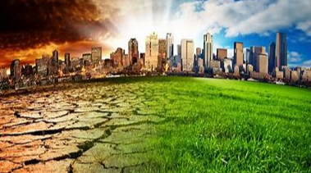
Note: All of these activities are suggested and what we hope to cover over the course of this half term.
RE/SMSC/British Values/PSHE
This term’s value is Peace and we will be aspiring to show this in our daily life.
Considering the Gospel section of the big story of the Bible, we will be asking ourselves ‘What would Jesus do?’ and considering how followers or disciples of Jesus can follow the example He sets.

Geography
In Geography, we will be investigating the main causes and effects of climate change whilst considering the changes we can make to our lives that can help lessen a global change in climate. Additionally, we will learn about some children around the world who campaign against climate change and its causes.
Maths
We begin the term revisiting factors, multiples and prime numbers. This should go to support our learning about fractions. We will learn about equivalent fractions and converting between mixed numbers and improper fractions. We will apply this knowledge to calculations involving fractions.

Music
In Music, we will be singing the New Year Carol that was written by Benjamin Britten. We will be appraising some of his work and comparing it to different versions of his work that has been re-worked using different genres of music.

English
During Read Aloud, we plan to finish off reading The Thieves of Ostia since the children have loved it so much.
In writing, we plan to write a persuasive argument which clearly states and opinion and addresses a counter-argument. The children will use a selection of conjunctions and adverbials that can be used to compare different arguments.
In reading, we have planned in some skimming and scanning sessions. We will also look at finding evidence to back up our opinions.

