Important information
Friendship
Solution
Kindness
Caring
Unkind
Problem
Relationship
Argument
Feelings
Bullying

Friendships are a type of relationship. How we act and how we treat others can have an impact on how we make others and ourselves feel. There are some things we can do to help problem solve within our friendships.

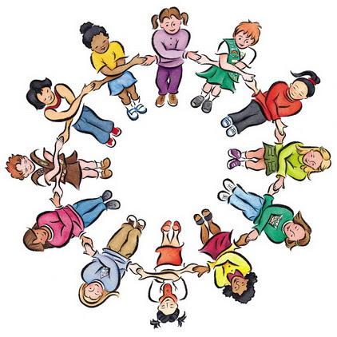

 | Lesson Question | What you will learn | Learning Review
1 | I can describe a range of relationships and understand how they are different to each other. | Discuss and identify how relationships with adults are different to relationships with friends.
2 | I can discuss what a friend is and how we can be a good friend. | Give a clear definition of what a friend is and how we can be a good friend to others.
3 | I can share and discuss how some actions might make people feel. | Looking at situations that can happen with our friends talk about solutions to fixing those problems.
4 | I can share problems that might come up with our friends and discuss ways which we can help solve these problems. | Looking at situations that can happen with our friends talk about solutions to fixing those problems – relevant to the pupils.
5 | I can describe why name calling and deliberately excluding someone is unacceptable. | Share and discuss what should be done if friends are making you feel sad or unhappy.
6 | I can discuss my own feelings and what I can do when I feel that way. | Looking at sadness, anger and loneliness what can we do to make ourselves feel happier and more in control of our emotions.

