Important information
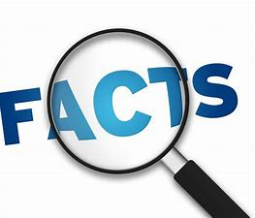
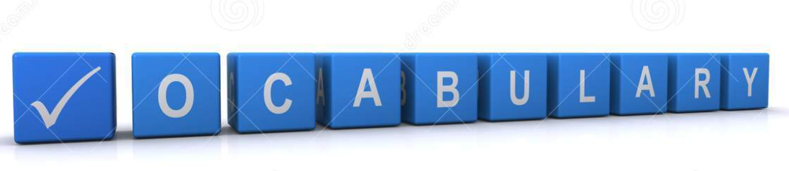
Note
Tune
Rhyme
Rhythm
Semibreve
Minim
Beat

To follow music notation and understand that musical notes have letter names. To understand that each note makes a different sound and when played in tune produce a beat/rhythm. To put lyrics and words to music to help play in time.
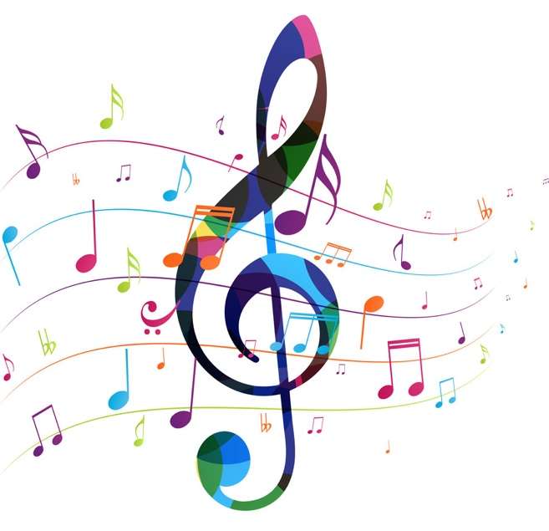

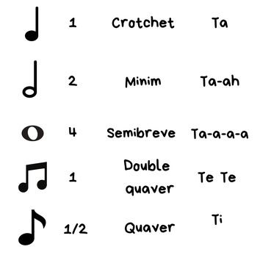

 | Lesson Question | What you will learn | Learning Review
1 | I can understand that music is played in a series of notes and corresponding letter names. | Name a semibreve and minimum, to understand that notes last a count of time. To give letter name to notes and understand that these make different sounds,
2 | I can name and play notes for a given amount of time. | To play alongside others. To understand that different notes are held for different amounts of time.
3 | I can play notes in time and alongside others. | To play and perform using musical notation alongside others.
4 | I can use known rhymes and song to help keep time and beat. | Using well known rhymes and lyrics to help keep pace and notation.
5 | I can add lyrics and play tuned instruments in time. | Pairing music and song together and understand how music note lengths add to overall performance.
6 | I can perform musical notation in time and apply lyrics. | To perform to an audience, playing musical notation in time and alongside others.

