Important information
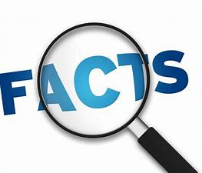
Chocolate
Cocoa
Farmer
Harvest
Melting
Tropical
Equator

Chocolate is made from cocoa beans; these beans are found in pods grown on cocoa trees. The main ingredients are: cocoa powder, cocoa butter, sugar and milk. Dark chocolate has the highest amount of cocoa powder in it whilst white chocolate has none. Cocoa trees grow in hot tropical places around the equator.

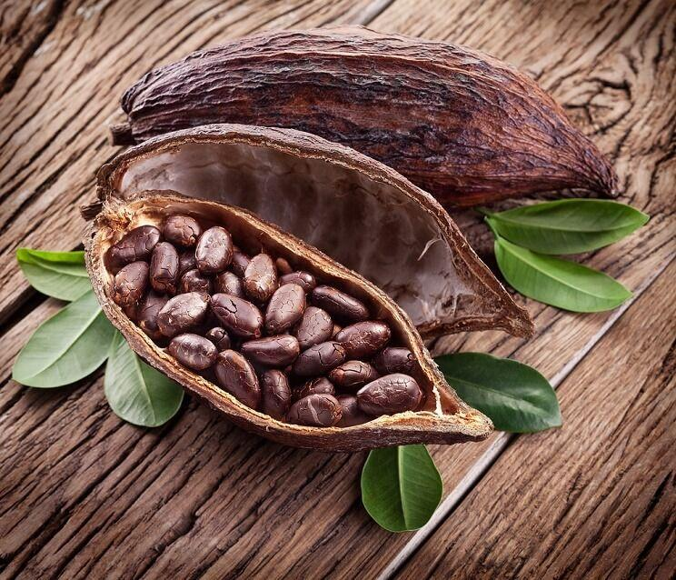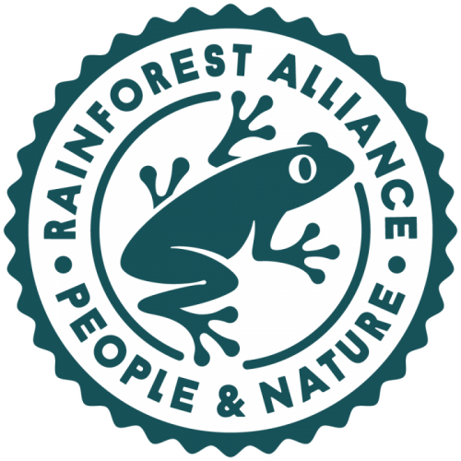

 | Lesson Question | What you will learn | Learning Review
1 | Where does cocoa grow?  I can locate using a range of resources. I can discuss weather and what it is like where plants grow. | Where in the world do cocoa plants grow? What is it like and why can we grow cocoa in Britain?
2 | I can compare locations. | Looking at the rainforest what is different about where we live and the rainforest – close investigation.
3 | Journey of a cocoa bean.  How do we get chocolate in the shops? | Link to the rainforest alliance. What is the rainforest alliance and what does it support? Fair farming and profit sharing.
4 | I can compare the beliefs of past cultures.  Aztec and Mayan chocolate | What did the Mayans and Aztecs think of chocolate? Brief introduction to the cultures.
5 | How did we get chocolate? I can describe how chocolate was brought in to Europe. | Introduction to Christopher Columbus – Advertising and describing the cocoa bean.
6 | History of chocolate – Cadbury and fry. I can chronologically order. | Ordering the timeline of chocolate in Britain.
7 | I can collect data. – To be fit where best placed. | Linked to D&T taste test – which chocolate will year one like best. Pictogram,

