Important information
Melt
Mix
Smooth
Crumbly
Delicious
Evaluate
Test
Shape
Size
Weight
Favourite
Milk
Dark
White

Chocolate is made from cocoa beans which are native to centeral and South America. There are many exisiting types of chocolate bars with all different types of toppings and fillings. Chocolate is now an everday item but historically has been used as currency and revered.
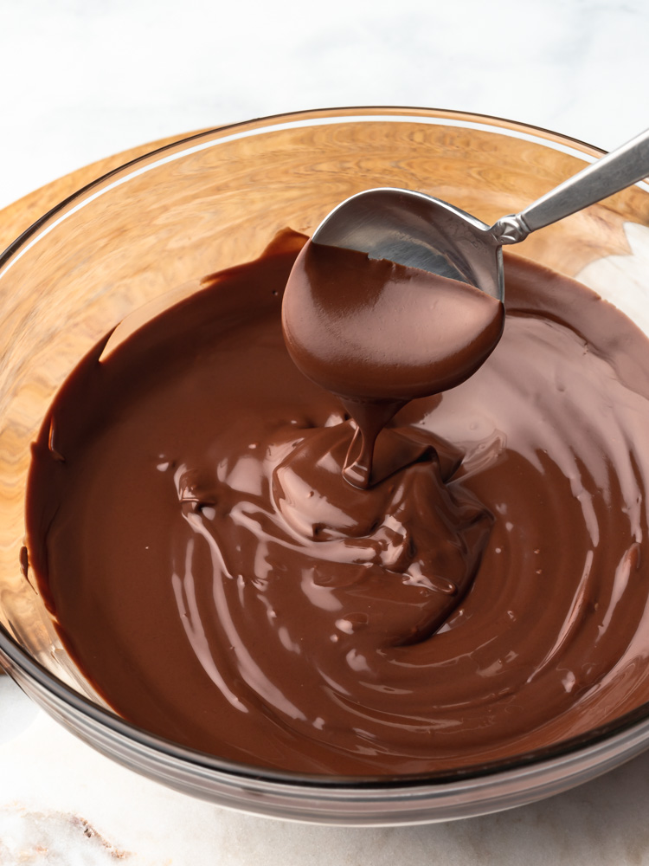
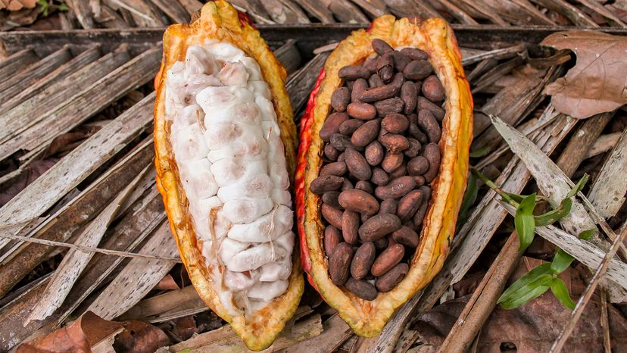

 | Lesson Question | What you will learn | Learning Review
1 | Where does chocolate come from? | Look at the history of chocolate. Where did it come from? What do we like about it? What can it be used for?
2 | Explore existing products.  Taste testing – which of the samples did we like best? What qualities do they have? Adjectives to describe and compare. | Using a range of samples – what do you like/dislike about each one. Think taste, texture, topping.
3 | Create design for own chocolates and packaging. | Use last lessons discussion to build a design for their own product – toppings, type of chocolate, flavours.
4 | Create own chocolate and packaging. | Melting and solidifying. Combning products and working to see which flavours work well together.
5 | Can you evaluate your product. | Look at your own chocolate. What went well? What would you change?

