Important information
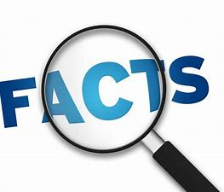
Primary Colour
Secondary Colour
Felt
Tone
Tint
Soap
Water
Wool
Karen Rao
Wave
Colour
Shape

Karen Rao is a felt artist who got in to felting after attending a craft fair with her children. She created her wave artwork and her animal hats using a traditional felting method.

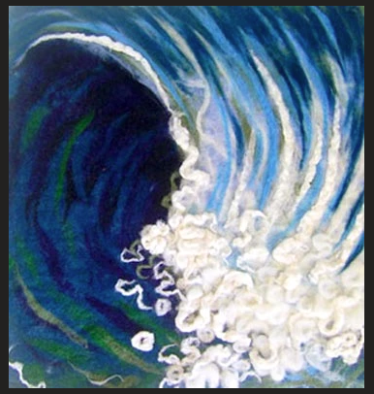
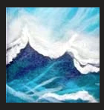

Primary colours are Red, Yellow and Blue

Secondary colours are Green, Orange and Purple.

 | Lesson Question | What you will learn | Learning Review
1 | Who is Karen Rao? | Examine some of their work. What do you like/dislike? Identify themes of shape, pattern and colour.  Know the terms primary and secondary colours.
2 | Know how felting is produced, trial the process to make a series of primary colours. | Using wool make a range of felts.  Can you make them darker to lighter. We call these shades.
3 | Understand how materials are bonded together. | Use traditional 3 step felting to create and join layers of colour.
4 | Know how to make felt and use the technique to create their own design. | Use traditional methods to experiment with joining of colours. Try out new ideas to create their own design.
5 | To use known methods to create their own designs using colour and pattern. | Design and create your own natural landscape artwork.
6 | Using materials to create a piece in the style of an artist. | Design and produce with purpose. Use an artist’s style and influence in your design.

