Important information
Individual
Teamwork
Rhythm
Movement
Space
Expression
Sequence
Order
Perform

Dance focusses on exploring how we can move in different ways. Look at how we can move and make sequences from adding movements together. Dance can be a form of expression to show ideas, feelings and mood.

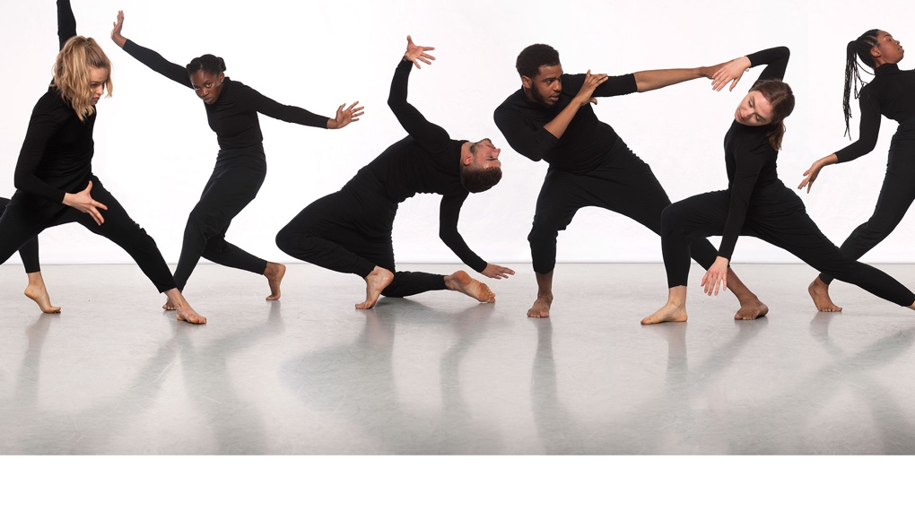

 | Lesson Question | What you will learn | Learning Review
1 | I can move in different ways. | To move with some precision in a variety of ways. To explore ways in which they can move and use space.
2 | I can move with control. | To look at controlling and making movement more precise.
3 | I can work individually and with others. | To work within space and alongside others with a range of movements.
4 | I can move to music showing expressive qualities of dance. | Communicate mood, feelings and ideas with movement. Use expression and action to convey these.
5 | I can creatively compose short dances. | Order and sequence movement with purpose. Recall and sequence movements in a performance. Explore, repeat and remember short sequences.
6 | I can participate in a performance. | Order and sequence movement for an audience. Recall and sequence movements in a performance. Explore, repeat and remember short sequences.

