Important information
Input
Output
Instructions
Algorithm
Keyboard
Keys
Debug

Objects on screen can be controlled and moved with algorithms. Pupils also need to be able to spot how instructions need to be changed to make objects move as desired.

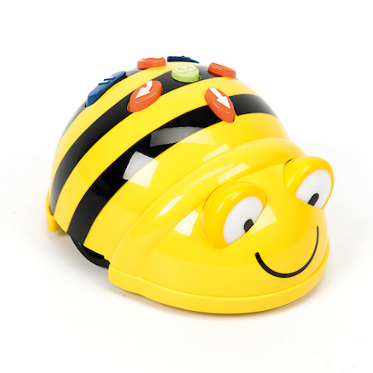

 | Lesson Question | What you will learn | Learning Review
1 | I can write a series of instructions. | Give clear and precise instructions to gain a series of movements.
2 | I can plan a journey for a programmable toy. | Using basic commands (forwards, backwards, right and left) to control a programmable toy.
3 | Learn that programmes respond to different types of inputs. | Use a range of inputs and gauge response.
4 | I can use the keyboard to control objects on a screen. | Learn and use a range of keys to control inputs on a screen.
5 | I can use one object to control another on the screen. | Use objects to inform how others move on the screen.
6 | I can begin to debug. | Use control and perform skills. Check and work through simple instructions to work out what is not working.

