Important information
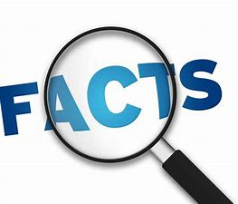
Primary Colour
Secondary Colour
Tone
Tint
Colour
Water
Blend
Gradient
Shade

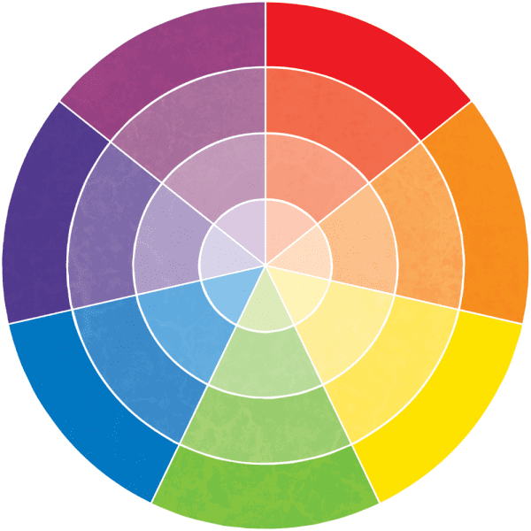

Primary colours are Red, Yellow and Blue

Secondary colours are Green, Orange and Purple. Tones are Black and white and can alter the shade of a colour.

 | Lesson Question | What you will learn | Learning Review
1 | What is a primary colour? | What makes a colour primary? How many different tones can you make with that colour?
2 | What is a secondary colour? How can I make a secondary colour? | I can mix primary colours to make secondary colours. I understand how the combination can make new colours.
3 | I can add tones (white and black) to change the shade of a colour. | The black and white is a tone. That tones can be used to alter colour and create a desired shade. Black makes colours darker and white makes them lighter.
4 | I can look at the work of Artists and describe what I like and what I don’t like about pieces. | I can comment on the work of another. I can pick out colours, texture and technique Iike.
5 | To use known methods to create their own designs using colour and pattern. | Design and create your own landscape picture in the style of an artist.  Use traditional methods to experiment with joining of colours.
6 | Using watercolours create own piece taking inspiration from an artist. | Design and produce with purpose. Use an artist’s style and influence in your design.

