Important information
Individual
Space
Muscle
Stretch
Lengthen
Bend
Hold
Breathe

Yoga is a great way to increase core strength and increase flexibility. It increases spacial awareness and the way our muscles move together.

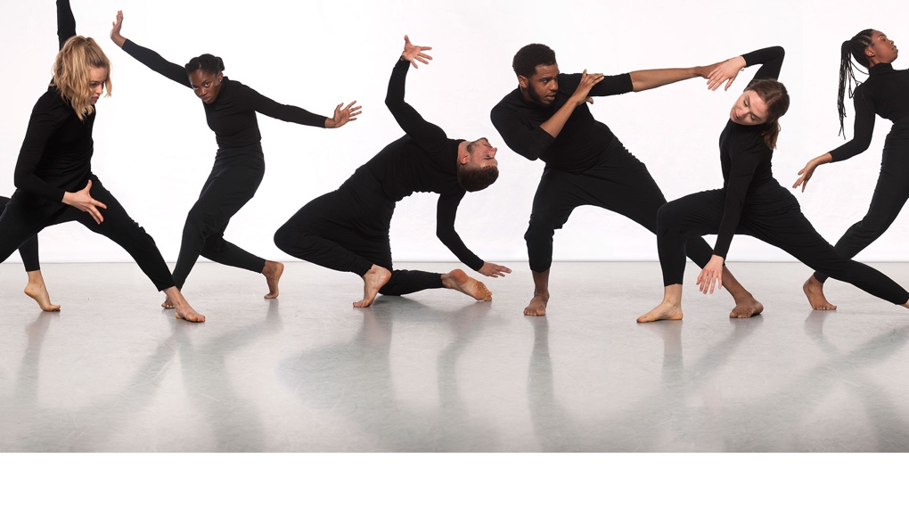

 | Lesson Question | What you will learn | Learning Review
1 | I can describe how my body moves and how the muscles are connected. | To move with some precision in a variety of ways. To explore ways in which they can move and hold a stretch.
2 | I can hold a pose focussing on stretch without injury. | To look at a comfortable range of challenge for stretching.
3 | I can sequence movements and move from one to another. | To work within a space and transition from one pose to another with control.
4 | I can sequence stretch and movement with precision. | To work within a space and transition from one pose to another with control. Find a comfortable balance for a stretch challenge.
5 | I can sequence stretch and movement with precision. | To work within a space and transition from one pose to another with control. Find a comfortable balance for a stretch challenge.
6

