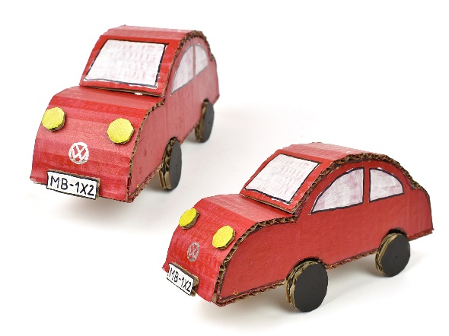
Important information
vehicle
wheel
axle
chassis
bodies
design
materials
evaluate
mechanism
function
model
tools
equipment
construction
construct

You will investigate a variety of different vehicles before undertaking the fun task of designing, making and evaluating your own vehicle. You will learn all about wheels, axles and chassis and how they are combined to make the framework of the vehicle, as well as how to create an eye-catching body.
KS1 - design purposeful, functional, appealing products for themselves and other users based on design criteria
KS1 - generate, develop, model and communicate their ideas through talking, drawing, templates, mock-ups and, where appropriate, information and communication technology.
KS1 - select from and use a range of tools and equipment to perform practical tasks [for example, cutting, shaping, joining and finishing
KS1 - select from and use a wide range of materials and components, including construction materials, textiles and ingredients, according to their characteristics
KS1 - explore and evaluate a range of existing products
KS1 - evaluate their ideas and products against design criteria
KS1 - explore and use mechanisms [for example, levers, sliders, wheels and axles], in their products

 | Skills | Lesson | What will you learn | Learning Review
To investigate a variety of  vehicles and their uses and features. | Can you identify a variety of different types of vehicles?  Can you identify the main features of a variety of vehicles?  Can you identify the uses for a variety of vehicles? | 1 | Explore and discuss a variety of different vehicles, their features and what they are used for.  Choose your favourite vehicle to compare, draw and label.
To investigate wheels, axles and chassis. | Do you know what wheels, axles and chassis are?  Do you know that there are two different ways of attaching wheels to axles?  Can you experiment with a range of materials and techniques to combine wheels, axles and chassis? | 2 | Understand how different parts of a vehicle help to make them work.  Practise attaching wheels to axles and chassis.
To be able to investigate ways of creating and decorating the body of a vehicle. | Can you choose materials to use as the body of a vehicle?  Can you identify different ways of combining materials to create the body of a vehicle?  Can you identify different ways of decorating the body of a vehicle including ICT? | 3 | Explore and discuss the different ways of creating the vehicle’s body.  Use a variety of different boxes and modelling equipment to explore different ways of creating the bodies of vehicles.
To be able to design a vehicle. | Can you design a vehicle to include wheels, axles, chassis and bodies?  Can you describe which materials and tools you will need to make your vehicles?  Can you discuss your designs and say what you think and feel about them? | 4 | Design your own vehicle using the techniques previously explored, as well as following the success criteria.
To be able to make a vehicle  based on a design. | Can you follow a design to create a vehicle?  Can you use a variety of materials and tools safely and effectively to create a vehicle?  Can you identify ways in which you could improve your products and amend accordingly? | 5 | Follow your designs to create and make your vehicles using a range of craft materials.  Make sure you are working safely and carefully.
To be able to evaluate a finished product. | Can you evaluate a finished product by identifying what you did well?  Can you evaluate a finished product by identifying what could be improved? | 6 | Share vehicles with your friends, making sure that wheels are working and the chassis is strong.  Evaluate your vehicle and explaining how your vehicle could be improved.

