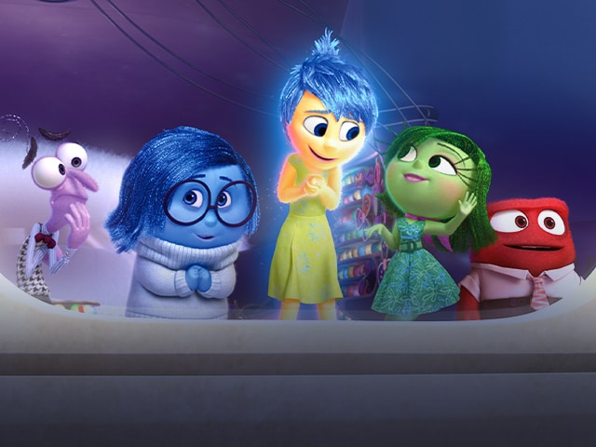
Important information
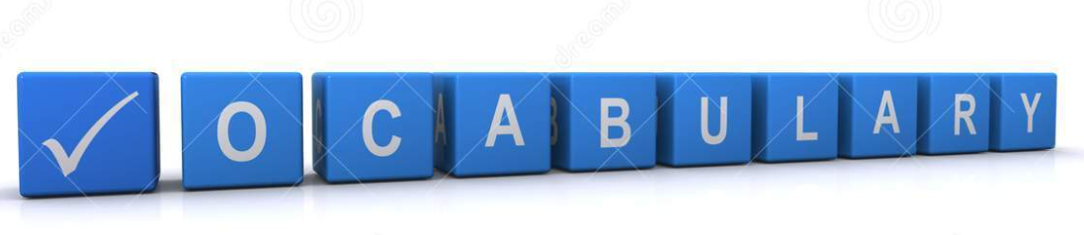
Emotions
Facial expressions
Feelings
Equal
Fair
Mental health
Strengths
Unfair
Kind
Unkind
Nice
Not nice

We will build upon your existing knowledge of feelings – happy, sad, angry, excited, scared etc. Having looked at when we might feel this way and what might cause that feeling we will develop how to deal with these emotions.

The way we act can affect how others feel and we need to think about the way we treat others. Treating others kindly sets, a good example and shows them how you would like to be treated. Some emotions are harder to control than others.

 | Lesson Question | What you will learn | Learning Review
1 | Recap –What makes you feel different feelings? Examples of when we have felt that way. | You will learn about keeping yourself safe, trust and trusted grown-ups.  You will learn about different types of feelings and the effects of these feelings.
2 | Who is a trusted adult to you? | You will explore strategies to deal with bullying and help minimise the long-term damage. We will talk about how best to identify trusted grown-ups.
3 | How can you stay safe online? | You will learn about keeping safe when using technology and the internet. You will talk about anti-virus/firewall software, keeping safe when watching TV and keeping safe when playing computer games and watching DVDs.
4 | How can you keep yourself safe? | You will learn about the KidSafe rules for keeping our private places safe and learn about good secrets and yukky secrets.
5 | What could you do when your friends argue? | You will learn about what to do when friends disagree or fight. You will identify trusted grown-ups other than mums/dads/carers.

