Important information
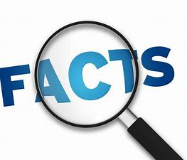
Cold/ freezing
Fruit
Nutrition
Flavour
Taste
Compare
Temperature
Frozen
Water

Pupils will try and compare existing products to analyse which ones they prefer. They will explore how Ice lollies are made and how we can easily make them with a variety of flavours.
Pupils will collect and record data for favourite flavours and then create their own design based on their findings. Pupils will then carry out and make their own product to analyse.

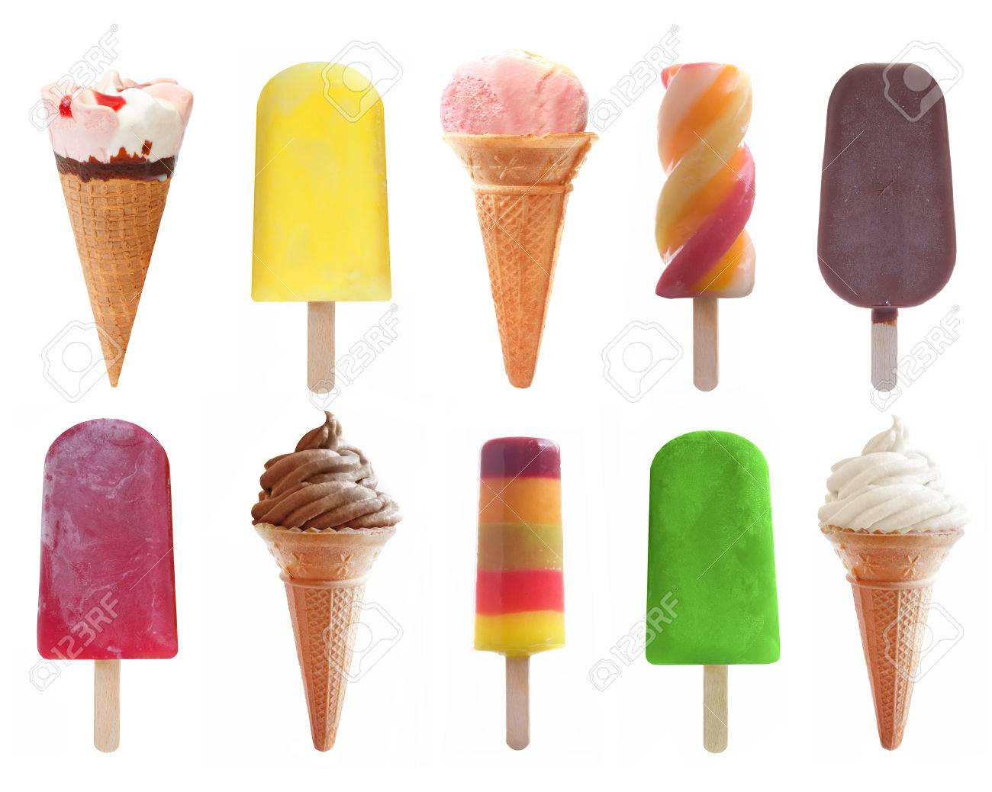

 | Skills | Lesson | What will you learn | Learning Review
To investigate a variety of  Ice lollies, their flavours and their designs. | Can you identify a variety of different types of ice lollies?  Can you identify common flavours used?  Can you identify what you like/ dislike about a product? | 1 | Explore, discuss and taste a variety of different ice-lollies.  Collect data for taste test and then tally year 1s favourite flavours.
To evaluate existing designs. | Looking only at the product, what do you like and dislike about how they look?  What do you like about their appearance? | 2 | Understand the different components of a lolly.  Discuss and share ideas about what is liked and disliked only by looking.
I can design and create my own product using existing products to help me. | Can you choose flavours to make your lolly?  Can you identify different ways of combining ingredients to make your lolly?  Can you identify different ways of decorating your lolly? | 3 | Explore and discuss the different ways of creating an ice lolly.
I can create my own product based on my design. | Can you follow a design to make a product.  Can you use a range or ingredients and tools to make a product.  Can you identify what went well and what could be improved next time. | 4 | Design your own vehicle using the techniques previously explored, as well as following the success criteria.
I can evaluate my design. | Can you identify what went well with your design.  Can you discuss what could have been done to make you product better. | 5 | Follow your designs to create and make your vehicles using a range of craft materials.  Make sure you are working safely and carefully.

