Important information
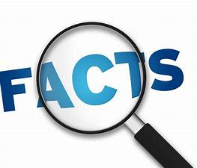
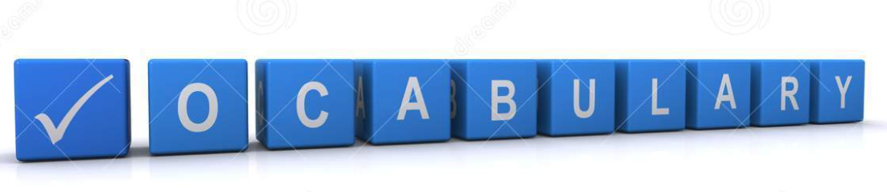Frottage
Pencil
Texture
Rubbing
Surface
Smooth
Rough
Bumpy

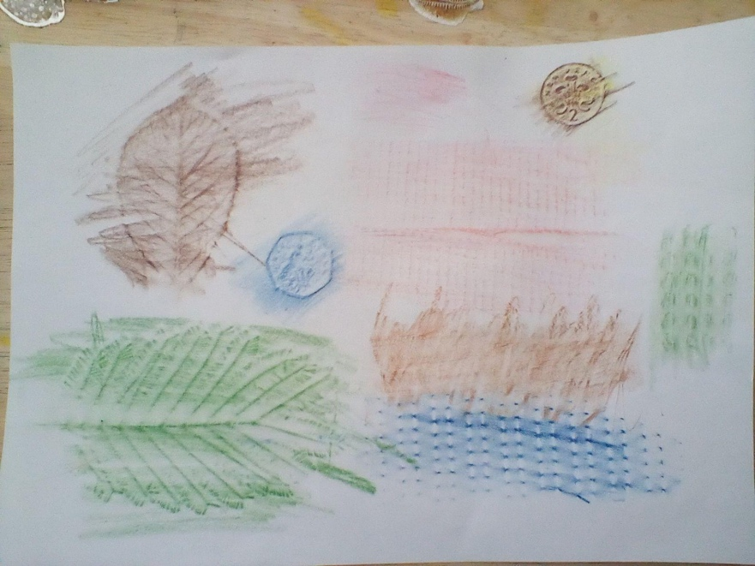

Frottage is a technique where pupils are able to mark make and build up creative images using the textures they can see around them. Taking a closer look at everyday items to discover their textures and how rubbings are made. They can then work to replicate these textures and use certain surfaces to create specific parts of artwork.

 | Lesson Question | What you will learn | Learning Review
1 | What is the best method for rubbing textures? | How the best rubbings are taken.  What frottage is.
2 | Finding textures outside of the classroom | Using the local area to find different textures and make rubbings of items.  Look for rubbings that match an adjective e.g. bumpy, rough, smooth.
3 | I can apply rubbings to match natural textures. | Use texture to create an image thinking about the surroundings.  Match textures to meet some specific criteria.  Create an overall image.
4 | I can replicate textures to create a purpose.  I can create different tones using a pencil  I can mark make to create texture. | Use a pencil to create tone and shade.  Match a texture or pattern to an everyday item.  Compare and find similarities in texture.
5 | I can use texture to create an image. | Using the practised skill of making texture to create a sketch with tone and depth.

