Important information
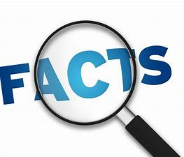
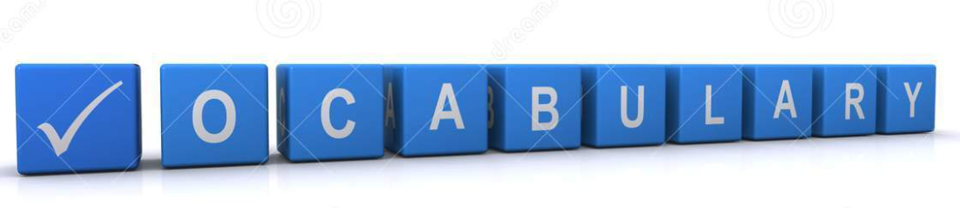
Prayer
Connect
Communication
Forgiveness
Hope
Praise
Thanks
Psalm
Blessing
Cross
God
Holy
Amen
Lord hear our prayer

This unit focuses on developing children’s understanding of prayer as a special way of spending time with God. Children will explore the vocabulary, actions, places and aids associated with prayer. Children will explore and compare how prayer is used across a range of religions. Children will explore how prayer is used across a range of religions.
The children will also explore the structure of prayer/psalms and have a go at creating some meaningful prayers themselves.

Contribution to SMSC
Spiritual Development - Developing their own views and ideas on religious beliefs and stories.
Moral Development –Thinking about why prayer is important – what are the reasons for prayer? Why is prayer an important way of communicating in religion.
Social Development- Considering how religious and other beliefs lead to particular actions and concerns.

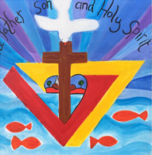
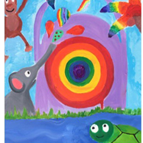
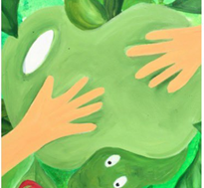
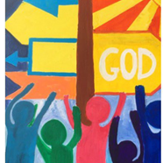
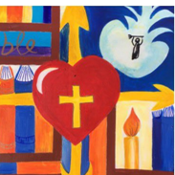
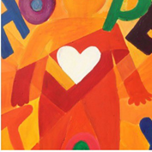
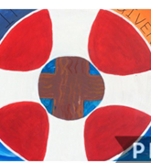

 | Each lesson uses the following skills | Lesson | What will you learn | Learning Review
 | What is a prayer?  What is a prayer and how is it used to communicate with God in Christianity? How do other religions use prayer to communicate | 1 | What is prayer?  How is prayer used?  How do other religions use prayer? | A prayer is……
 | Giving thanks – How are prayers used to give thanks?  What do we do when we prayer, is prayer always done as collective? | 2 | Christians often gather to pray together.  That prayer can be used as an expression of thanks.  Christians and other religions use prayer to show what they are grateful for.
 | How is prayer used to say sorry? | 3 | Revisit the idea of free will and discuss how we are responsible for the choices we make.  How do other religions ask for help changings and improving.
 | How is prayer used to help make up for the wrong choices? | 4 | To again disucss working making the right choices.  Think about redemption and how we can make up for wrong choices.
 | How are prayer mats used? Islam | 5 | What prayer mats are and how they are used.  What their significance is.  Designing a relevant prayer mat to help them think about connecting with others.
 | Producing our own prayers for those around us – prehaps thinking of Ukraine. | 6 | Thinking about how we can help others in need.  Discuss how prayer is used to think about and care for others.

