Important information
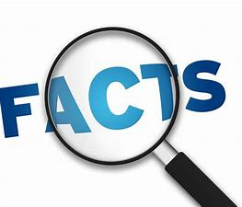
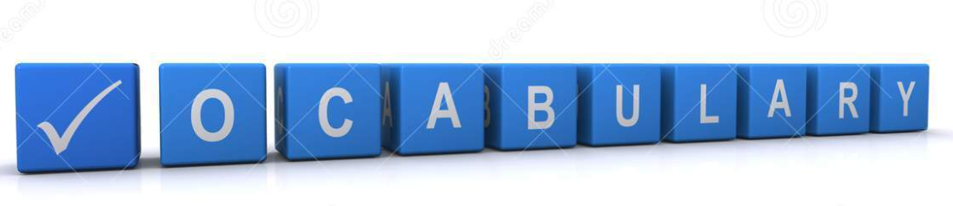Individual
Space
Balance
Stretch
Star jump
Pike
Straight
Pointed Toes
Bend
Hold
Breathe
Straddle
Tuck jump
Support

Gymnastics will allow children to explore the space around them and build on their stretching and balancing skills. They will continue to develop their sequencing skills, building skills and positions in to a routine.

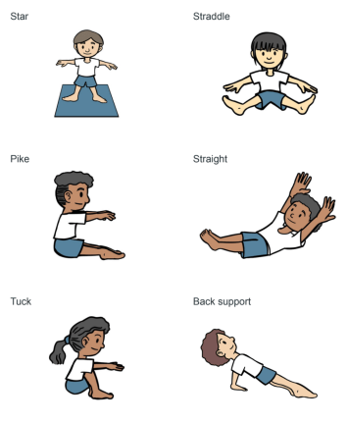

 | Lesson Question | What you will learn | Learning Review
1 | I can use my body to make simple shapes. I can concentrate on my bodys form as a gymnast. | To move with some precision to create a variety of shapes. To be aware of how the body moves and how we can stretch different muscles.
2 | I can move with control and increasing precision. | To move with control and be spacially aware of their surroundings including others.  To perform a range of movements with increasing accuracy with their form.
3 | I can balance using different parts of my body. | I can perform
4 | I can sequence and link movements/skills. | To work within a space and transition from one pose to another with control. Find a comfortable balance for a stretch challenge.
5 | I can use apparatus safely and effectively. | To work within a space and transition from one pose to another with control. Find a comfortable balance for a stretch challenge.
6 | I can perform a sequence of movements for an audience. | To sequence and order movements.  To hold balances.  To be aware of performing to an audience.  To evaluate and give feedback to others.

