Important information
Feelings
Health
Sun
Burns
Brush
Clean
Food
Water

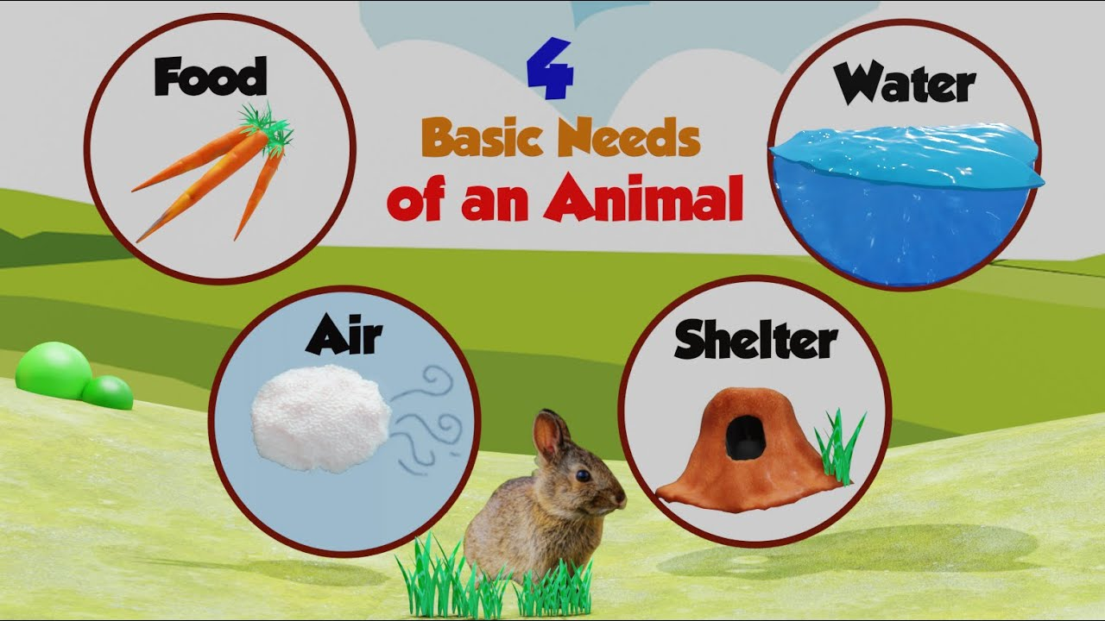

Pupils will already have a basic understanding of what living c creatures need to survive and things that they like. We will build upon what pupils know about ‘need’ and ‘want. Animals and humans share many of the basic needs and some of the wants.

We will explore how different animals are looked after as well as how to look after themselves in different types of weather.

 | Lesson Question | What you will learn | Learning Review
1 | What do all creatures need to survive? How do we differentiate between need and want? | What is the difference between need and want?  How do we know the difference?  What needs do all living creatures have in common?
2 | How are reptiles taken care of? | How are reptiles needs different to others animals?  What are their diets like?  What environment do they need to be kept in?
3 | How do we take care of mammals/ farm animals? | How are farm animals looked after?  How are their needs different to a reptile?  What is their environment like?
4 | How do we make sure we take good care of our pets? | What pets do year 1 have?  How are they looked after?  What can we do to make sure we are looking after our pets properly?
5 | Sun protection – what can we do to take care of ourselves in the sun.  (This may be moved depending on weather when we return). | What are the effects of being out in the sun?  How can we make ourselves safe when out in the sun?  Why should we do these things even when it is cloudy and hot?

