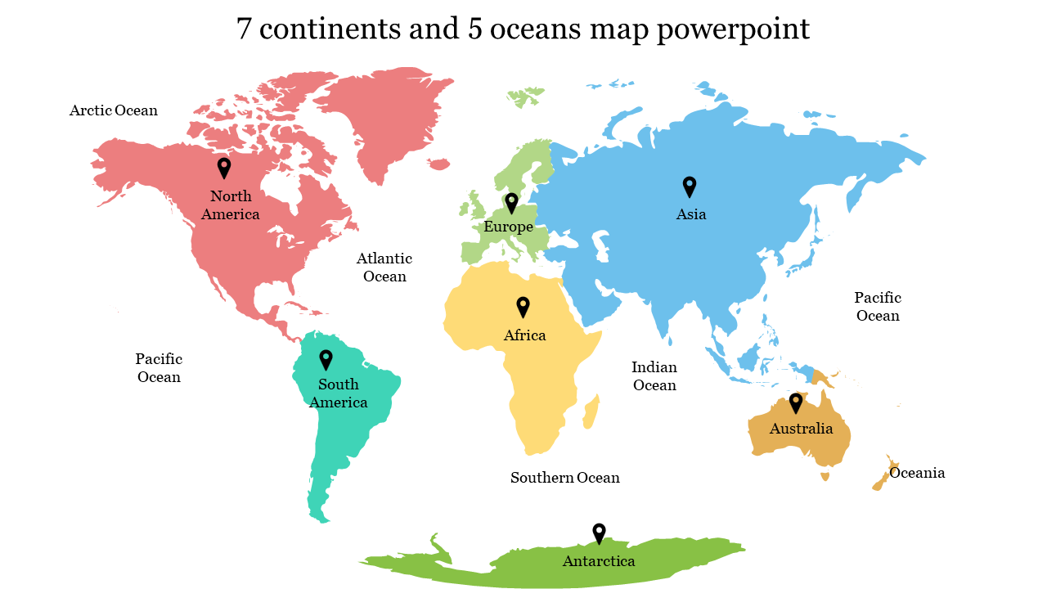
Important information
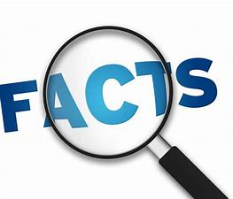
Continent
Ocean
United Kingdom
North America
South America
Europe
Asia
Australia
Antarctica
Climate
Compare
Similar
Different
Clothing
Animal
Habitat

Pupils should develop knowledge about the world, the United Kingdom and their locality. They should understand basic subject-specific vocabulary relating to human and physical geography and begin to use geographical skills, including first-hand observation, to enhance their locational awareness.

Pupils will be able to:

Name & locate the world’s 7 continents and 5 oceans

key human features, including: city, town, village, factory, farm, house, office, port, harbour and shop

key physical features, including: beach, cliff, coast, forest, hill, mountain, sea, ocean, river, soil, valley, vegetation, season and weather.

Use basic Geographical vocabulary to refer to key human and physical features.

 | Lesson Question | What you will learn | Learning Review
1/2 | Where in the world are we? Looking at the location of school and our locality in relation to the poles and other continents. | Where about in the world do we live? Can I locate places I know on a map? Use of Digi maps to find areas that we know and recognise. Label the continents and seas.
3 | How do we adapt for different climates? | We dress differently depending on where we are going? How differently would we need to dress for different climates?
4 | Who live in cold climates? How are their lives different to ours? | What it is like to live in a cold climate. What is similar and what is different to our lives.
5 | What is it like to live in a different climate? | Diary entry looking at what it is like to live in Antarctica. What would you miss about where you live?
6 | Which animals live in cold climates? How are they adapted to living here? | Explore which animals live in different climates and how they are adapted. What an adaptation is and how it helps them survive.
7 | What is the landscape like in Antarctica? | You will use quality adjectives to create a description of a landscape in Antarctica. Looking at how the different areas similar or different to our locality.

