Important information
Zero
Un
Deux
Trois
Quatre
Cinq
Six
Sept
Huit
Neuf
Dix

This unit allows children to recogise and develop their understanding for numbers 0 – 10 in French. Pupils will learn and reinforce their understanding through a series of fun and interactive games/ songs.
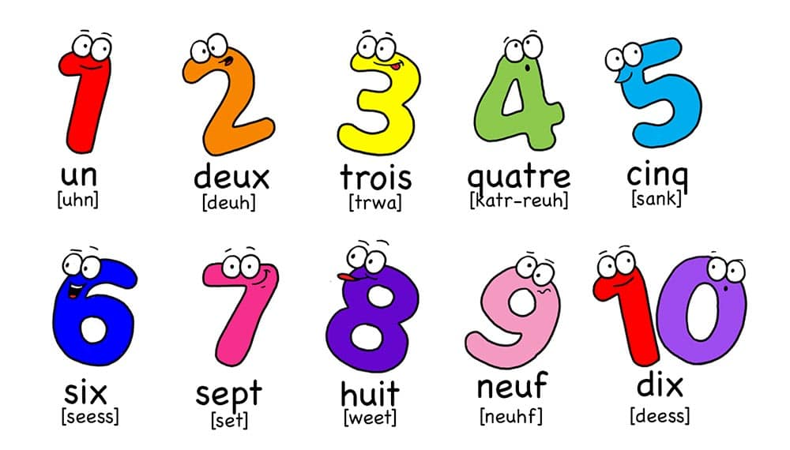

 | Lesson questions | What will you learn | Learning Review
1 | What are the numbers 0 – 5 in French? | What the pronunication and number names are in French for numbers: 0, 1, 2, 3, 4 and 5. | 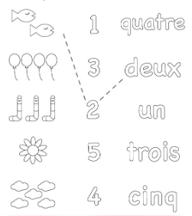
2 | What are the numbers 0 – 5 in French? - Recap and reinforce. | What the pronunication and number names are in French for numbers: 0, 1, 2, 3, 4 and 5.
3 | What are the numbers 6 – 10 in French? | What the pronunication and number names are in French for numbers: 6, 7, 8, 9 and 10. | Colour and match the number with the digit.  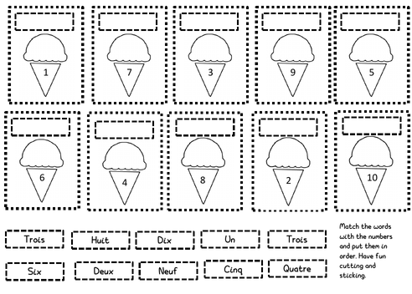
4 | What are the numbers 6 – 10 in French?  - Recap and reinforce. | What the pronunication and number names are in French for numbers: 6, 7, 8, 9 and 10.
5/6 | Recap and reinforce the numbers we have learned with a series of games where pupils can independently and as a group put to use what they have learned. |  | Video number cards pupils saying the number in French.

