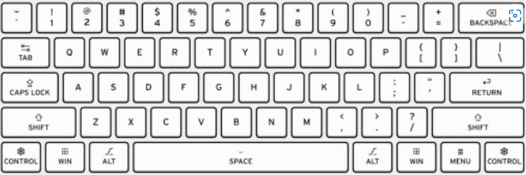
You will look at how to type quickly and accurately on a keyboard.
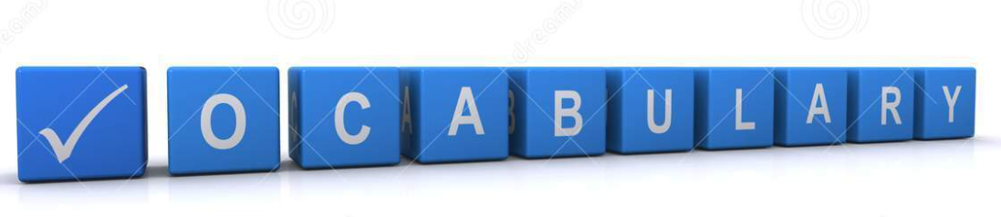
Technology
Microsoft Word
Word processing
Typing
Font
Undo
Redo
Editing
Symbols
Save
Files

You will learn how to save documents and name them. You will be able to find them and open them again to use again.

Redo
Undo
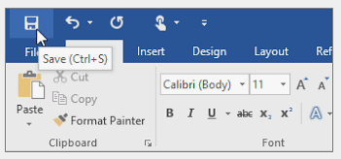
Font size
File - Save

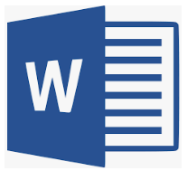
Italic text
Font name

Microsoft
Underline text
Bold text

Word
 | Lesson Outcome | What you will learn | Learning Review
1 | I can type on a keyboard | You will look at typing and how we can be efficient with this. You will learn key skills such as typing with two hands, how to get capital letters and what to do after each word. We will practise this skill by typing different things on a Word document | Can you shade in the keys you would use to type your name?
2 | I can type symbols and save files | You will use your skills from last week and build into this adding symbols. You will type different things using symbols. You will learn how to save your work on to the laptop | Which symbols did you manage to use?  ? @  ! &
3 | I can edit text | You will be given a text with some errors in and your job is to use backspace, delete and your arrow keys to change the mistakes | How easy did you find it to find and change the errors?
4 | I can use undo and redo to change my work | You will build on other week’s work and know that you can use undo if you make a mistake that you didn’t mean to and redo if you want something back you accidentally got rid of | Why might you use the undo or redo button?  __________________________________________________________________
5 | I can select and format text | You will look at how you can select text to change it. You will try changing the font using Bold, Italics or Underline and if you can, change the font type and size | What do you click on in your Word document to underline a piece of text? Circle the correct answer.

