Important information
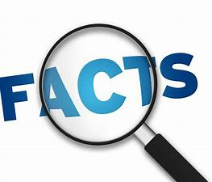
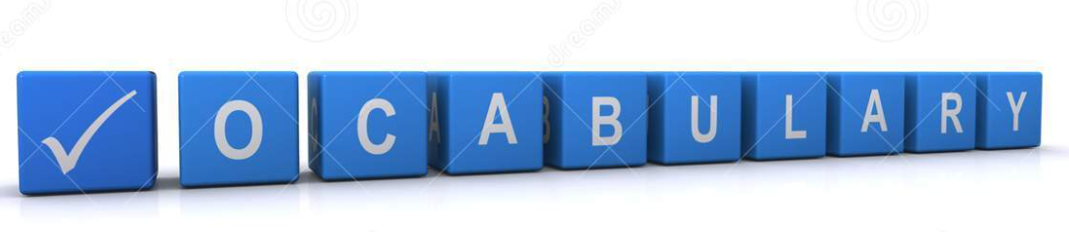
Detached
Semi-detached
Flat
Bungalow
Chronological
Past
Present
Similar
Different
Sources
Artefacts
Historian
Modern
Victorian
Compare
Investigate
Enquire

Pupils will be able to explore homes from the past with homes in the present day. Explore how daily tasks have changed to those they are familiar with. Understanding how homes change with new discoveries and over time.

Pupils will develop their enquiry skills using historical sources, artefacts and learn how historians learn about the past. What can simple things tell us about the lives of those in the past.
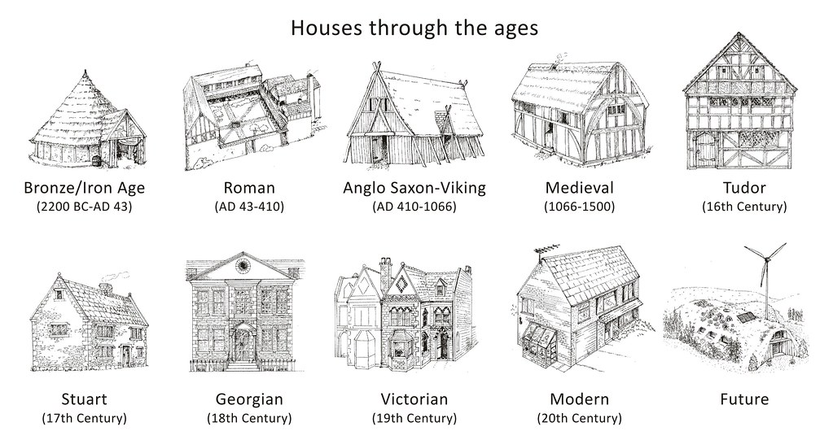
 | Lesson Question | What you will learn | Learning Review
1 | What types of homes do people live in? | Looking at housing types pupils will identify which type of home they live in. They will learn the differences between them and label.  (Estate agents). | I live in a house.
2 | Can I order chronologically? | Looking at features in a modern home and a homes from the past - what is similar and what is different? Looking at objects pupils will order chronologically. | Which item surprised you?
3 | Can I order chronologically?  What were Victorian homes like? | Discuss why certain rooms such as a kitchen is so important. Looking at items from the past and modern kitchens can we sort which time period the items came from? | Match with the correct label.  Present  Past
4 | How were Victorian bath and bedtime routines different? | Pupils recap the artefacts they looked at last lesson and recall what they were used for. Compare how bath and bedtime is different in Victorian times. Why would it take more time? | Why would bath time take longer? Tick the correct answer.  - Victorian’s didn’t have running hot water.  - Victorian’s took longer in the bath.
5 | What do sources tell me about how others lived?  Rich Vs poor. | Pupils will compare the lifestyles of rich and poor Victorians. | Name one difference between the way the two classes lived.
6/7 | Trip to Beamish – Lesson to follow Diary entry. Can I place myself in role of someone from the past using my experiences? (H/M)  Can I recount my day in first person? (L) | Following our trip, the pupils will recount their day either in role of someone from the past or as themselves. Talking about experiences and objects from personal experience. | My favourite part of the day was….

*Some lessons to be determined based on the pupil’s interest in time periods.

