Important information
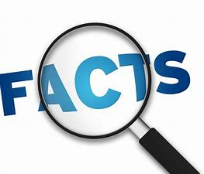
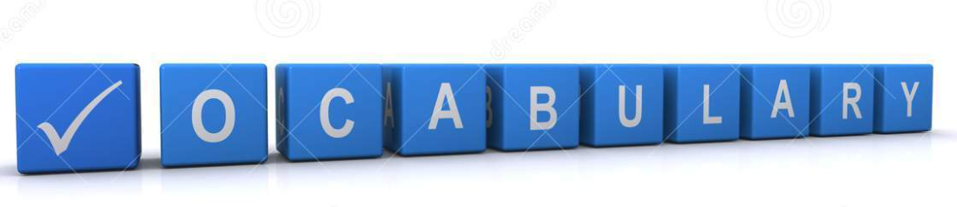Pressure
Pencil
Imprint
Coating
Surface
Smooth
Rough
Pressed
Ink
Paint
Wash

Prints are made using cut or pressure engraving. Pupils will explore how simple prints are made and how textures are picked up on. Pupils will experiment with a range of everyday items and see how they can be used to produce prints. They will then look at incorporating prints and design to create a final print.

We will look at linking our topic of homes within our designs.

 | Lesson Question | What you will learn | Learning Review
1 | What is a print and how is it produced? | How prints are made and what makes them different to other art techniques. | What is a print?  .  .
2 | What is the best technique for making a print. | Using potatoes and simple stamps what is the best technique for gaining a print? Think about paint amount | What makes a good quality print?  .  .
3 | How are lines and patterns printed using a polystyrene sheet? | Use a small piece of polystyrene look at how lines and pattern are printed when done ourselves. | What makes the print clearer?  .  .
4 | I can consider space and thickness of design/lines for printing? | Design in pencil your print design. Thinking about homes and city scapes – apply what you know about how prints are produced. | What is your design of?  .
5 | Can I replicate a design considering how the design will look as an end product? | Produce by replicating design on to polystyrene sheet. | How do you feel about your design?
6 | Can I produce a relief print from my own design? | Make prints – experiment with different coloured versions. | How well did your design work?

