Spring
Summer
Autumn
Winter
Hot
Cold
Wind
Rain
Sun
Fog
Snow
Thunder
Hail
Season

Important information
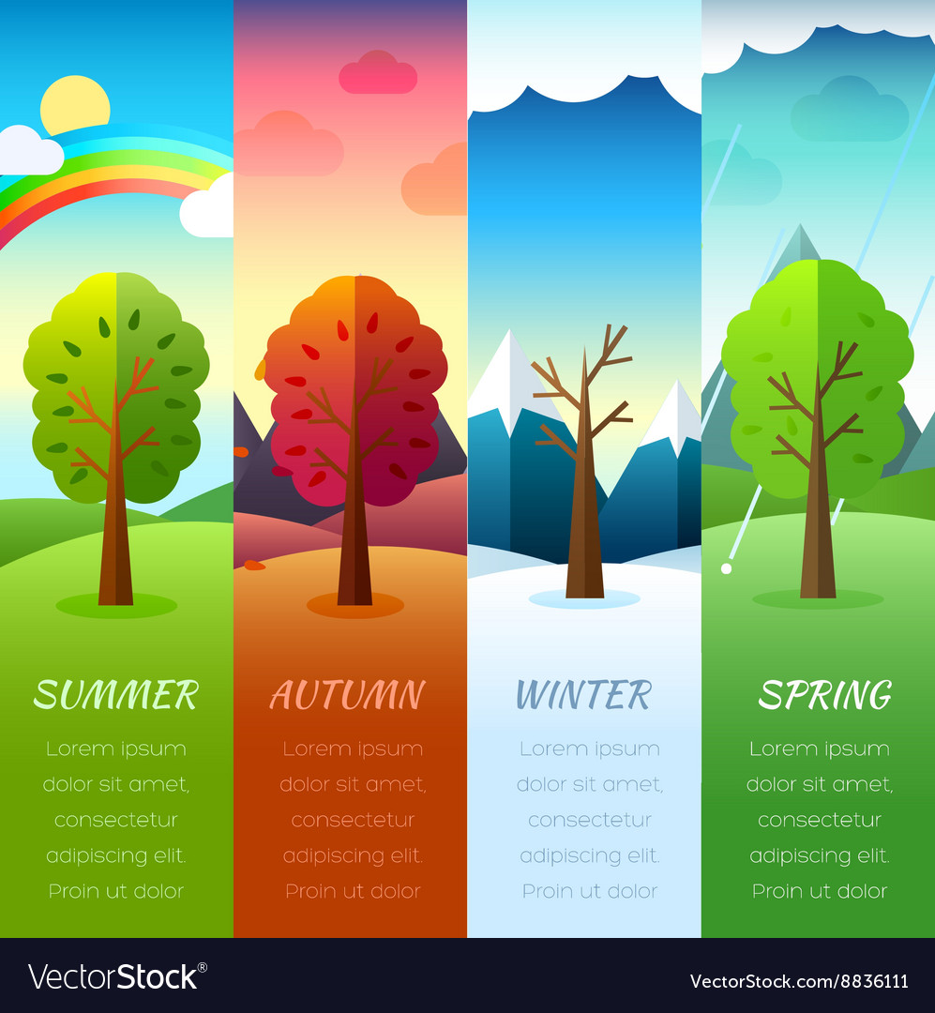

Pupils will learn about the four seasons we have in a year and the weather that is common with each of those seasons. You will observe the weather and collect data over a short period of time.

You will think about the weather you have already experienced and spend some time observing the weather locally.

Pupils will be able to consider the types of weather each season gives us in this country. We will then look at how seasons can be different in different places.

 | Lesson Question | What you will learn | Learning Review
1 | Pre-assessment: What do we know about weather? | Looking at the seasons pupils will match the weather we can see in those months. You will start to looks at current weather conditions and explain how you would dress for each kind.
2 | What are seasons? | You will share what seasons we have in a year, and learn about the weather we usually see in these seasons. Matching. | In Winter the weather is usually  Cold Hot Warm
3 | What do shadows tell us about the time of day? | Making a sundial you will learn about how the Sun and Earth rotate. You will learn how this changes throughout the day. Using chalk, we will draw around shadows and see how they change throughout the day. | Your shadow is longer at which part of the day?  Morning Lunch time Night
4 | What is the weather like based on weather forecast? | Creating a 5-day weather diary and comparing to the weather forecast. Making weather reports like a presenter. | Which day was the coldest?
5/6 | How can I present my findings?  Presenting data. | Using data of weather pupils will present their data with a pictograph or in a bar chart. | Which type of weather did you see the most of?
6/7 | How do we gather information about the weather? | Pupils will learn about how rain, wind and temperature is measured. We will look at measuring with each of the devices. | To measure rain, we use a:  .

