Important information
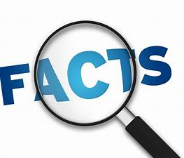
Christians
Kind
Forgiving
All powerful
Fair
Lord
King
Gentle
Example
Role model

This unit focuses on developing children’s understanding of how Christians view God, that he is thought of in many forms. To understand that parables tell us about how God is and teaches Christians how God wants them to be with others.
Pupils will use the relationships they have with others to explore the relationship between Christians and God. The father like role and what Christians believe about God’s parental guidance.

Contribution to SMSC
Spiritual Development - Developing their own views and ideas on religious beliefs and stories.
Moral Development –Thinking about why Christian’s relationship with God is important.
Social Development- Considering how religious and other beliefs lead to particular actions and concerns.

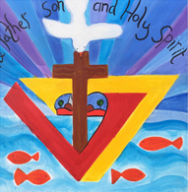

Lesson | Key Question | What will you learn | Learning Review
1 | How is God like a father? What does this teach Christians about his nature? | Read the parable of the Lost Son, Christians see God as a father figure who is there to guide them and teaches forgiveness when they lose their way. | The Father Showed is son  just like God shows .
2 | How can Christians show they are loving and forgiving in return? | How do Christians show their love and forgiveness to God? E.g. prayer, singing, go to church, love and look after others. | Name three ways Christians can show love to God.  1. .  2. .  3. .
3 | How can we show forgiveness in our lives? | What happens when we do something wrong in school? At home?  Revisit the four main types of prayer:  Forgiveness, praise, saying sorry and asking for something. | Name one of the four types of prayer.  .
4 | Is forgiveness only important for Christians? Why can it be hard to forgive? | Philosophy for children – Who should be forgiven? | Who is forgiveness important to  .
5 | The story of Jonah – how was Jonah feeling? Was it important for Jonah to go to Nineveh? How and why did God find him? | That it is important for everyone to practice and show forgiveness for others. What can we do to show others we forgive them? | Why did God look for Jonah?  .  .
6 | How do Christians learn about God? | What do Christians do to learn about God – prayer, song, worship together and apart. | What quality do you think is important in any God?  .

