Important information
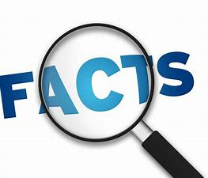
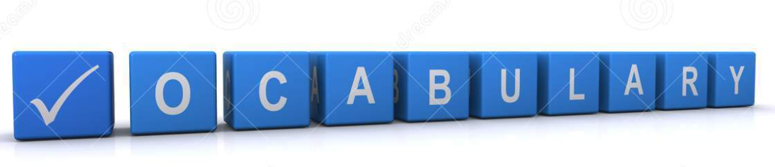
Speed
Balance
Control
Manoeuvre
Increase
Decrease
Movement
Equipment

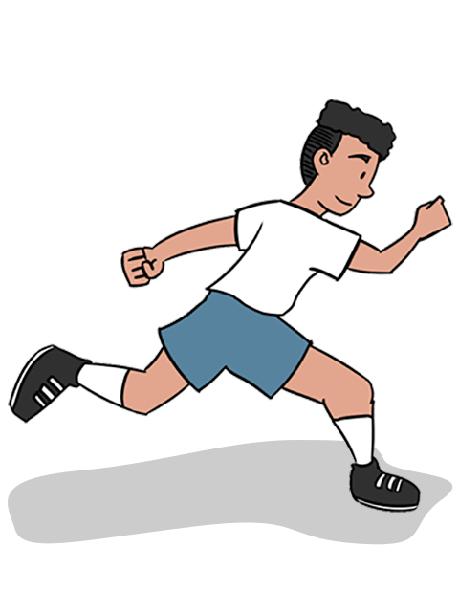
Pupils will develop ways to build speed and look at what they can do to increase their pace. They will look at endurance and how we build our stamina. Pupils will look at how they can move their body to dodge and move around others/ equipment.

During PE sessions we will discuss what athletes do to build their stamina for a better performance. What makes us healthier, faster and more controlled?

 | Lesson Question | What you will learn | Learning Review
1 | Move in to space.  How can we move effectively working around others? | How does moving in to space help us perform better? Why is space important when competing. | To perform and my best I need to have plenty of  .
2 | How can we control our body and equipment when running, throwing and jumping? | Muscles are connected and help us move in different ways. The way we move helps us perform better for different tasks. | To make my body move in different ways, I need to think about my  .
3 | How can I land safely when jumping? | What measures can we take to make sure we land safely. What can happen if we don’t land safely. | What can happen if we don’t land safely.
4 | Can I run and jump on the balls of my feet? | Balance and movement to maintain movement on the balls of his feet. | One rule for keeping my body safe is…
5 | I can show a correct pull throw technique? | Practice and use a technique for throwing with accuracy. Using a target and aiming with increasing accuracy. | Name two things to help with aim  1. .  2. .
6 | Can I complete against others and can I beat my personal best? | Using a range of techniques to perform well against others and previous performances.  Continue to develop good sportsmanship. | I was best at:  .  I would like to get better at:  .

